First Step:

My annualized volatility is **0.122**

* I got to this value by using the Target Return portfolio’s monthly risk of 0.0358 in Exercise Set 5b and then multiplying by sqrt(12) which annualizes the return. This gives me a value of approximately 12.2% annualized volatility

My annualized expected return is **0.083**

* This was my portfolio return in Exercise Set 7’s Base Case annualized return

(0)

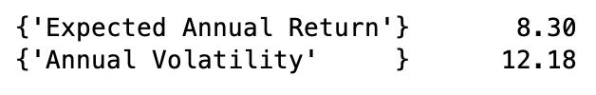

1. and (2)

First 10 rows:

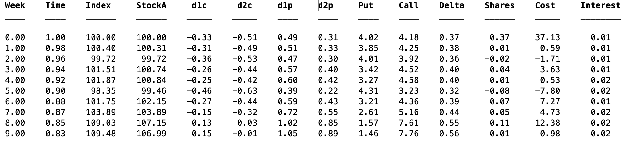

Last 10 rows:

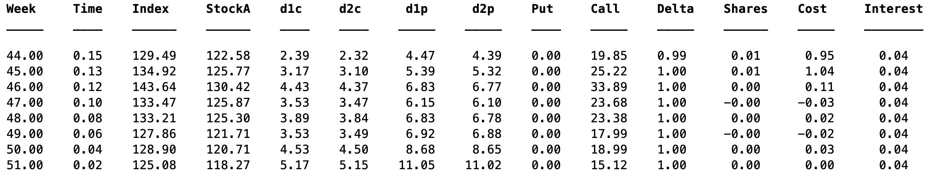

(3)

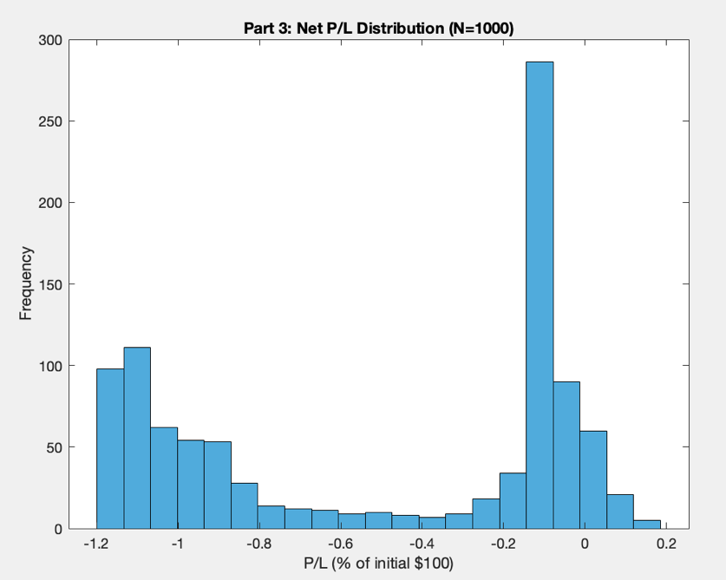

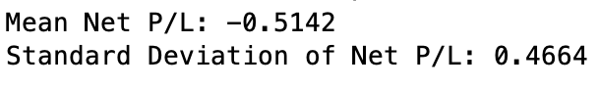

(4)

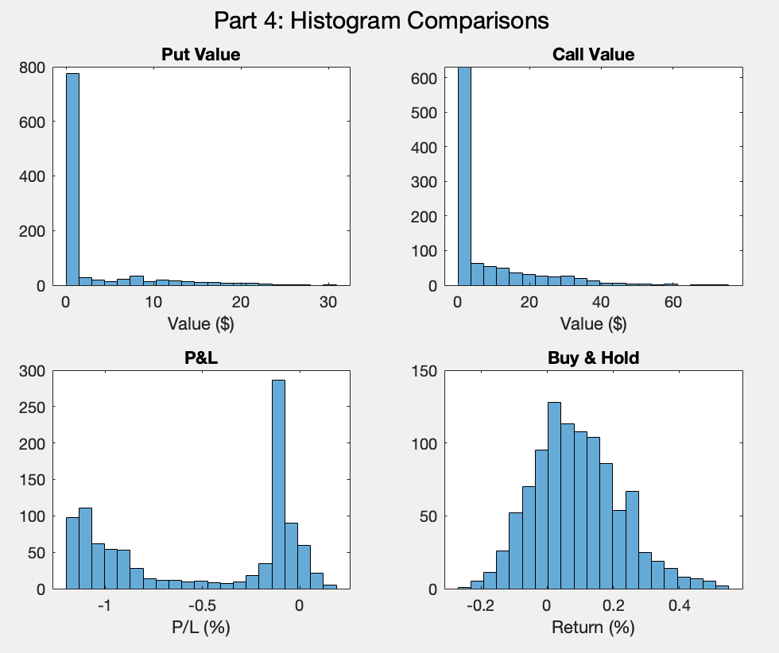

(5)

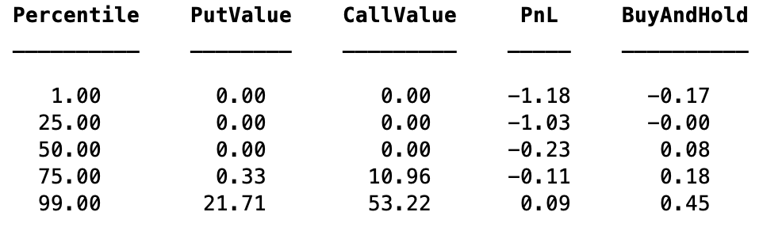

* Both the put and call options have no value from the 1 to 50th percentiles, but then start to show value at the more extreme ends, of market movement (75th to 95th percentiles). This is typical of put/call behavior.
* The PnL “collar” strategy has negative returns in 75% of the scenarios and provides decent downside protection (-1.18), especially compared to the Buy and Hold strategy (-0.17). However, PnL also significantly caps the upside potential (0.09) compared to Buy and Hold (0.45).

(6)

* The first thing that jumps out at me about the putValue and callValue histograms is that they are both highly right skewed, with most of the outcomes near the 0 to 100 range.
* The putValue behavior depicts that most of the scenarios have very little value, however they pay have greatly in adverse market scenarios
* The callValue behavior shows a similarl depiction to that of the putValue histogram, however in general the payoffs are a little greater. Additionally, in favorable conditions, you can win big
* Overall, both distributions demonstrate that when dealing with options payoffs, they don’t go below 0 and can potentially reach very high values under the right conditions

(7)

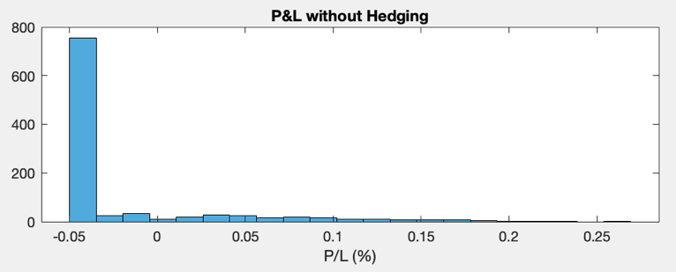

* When looking at PnL Unheged, we see that the distribution is heavily right-skewed and tends to concentrate around -0.05, indicating that there is little variation and consistently generates small losses. This demonstrates that without delta hedging, this strategy generates small gains and occasional large losses

(8)

* The collar strategy has a negative mean return of approximately 50% while the Buy and Hold strategy has a positive mean return of approximately 10%. The percentile distribution demonstrates that the collar strategy produces losses in about 75% of scenearios, while Buy and Hold is profitable in more than 50% of scenarios. However, the collar strategy has marketably better downside protection. Overall, the collar strategy would be preferable for highly risk-averse investors how are more concerned with limited maximum losses as opposed to maximizing expected returns. Additionally, if one suspects that the market will likely have extreme downsides in the near future, than a collar stategy would seem more appealing.